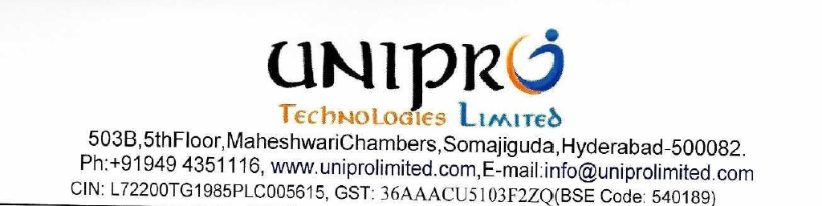

Unaudited standalone financial results for the Quarter ended June 30, 2026

The unaudited standalone Financial Results of UNIPRO TECHNOLOGIES LIMITED (‘Unipro’) for the quarter ended June 30, 2026 have been filed with the Stock Exchanges as per Regulation 33 of the SEBI (Listing Obligations and Disclosure Requirements) Regulations, 2015. Financial Results are available on Unipro website www.uniprolimited.com, and also on the website of the Stock Exchange, i.e., www.bseindia.com.

Please scan the below Quick Response (QR) Code to access the Q1 FY 2026-27 Results ended June 30, 2026:

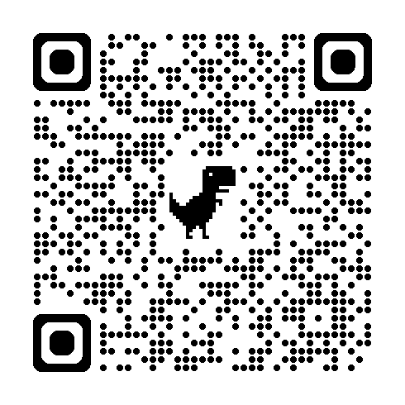

For UNIPRO TECHNOLOGIES LIMITED

VENKATA RAMANA REDDY DANDU
MANAGING DIRECTOR
DIN: 02957936

